Using Exploratory Methods for Improving Disability Support Services

Michael Wolf-Branigin, Ph.D.
George Mason University Department of Social Work
Arlington, Virginia

Technology Assistance and Resource Centers, CTCs, and other community organizations provide persons with disabilities with technology access and training, and other technology-based social services. By using geographic information systems (GIS) and exploratory spatial data analysis (ESDA) to identify clusters of activities, community practitioners can better plan for supports and services. ESDA simply seeks to provide good descriptions, often in the form of maps, of available data. By using ESDA, stakeholders in organizations improve their ability to detect patterns, relationships, extreme values and so forth. For example, if it appears that all persons with disabilities tend to live in the same city neighborhood, this may indicate to planners the need to establish homes in other neighborhoods. These technologies are particularly useful given the availability of location information such as addresses, census tracts or zip codes. Using GIS and ESDA provides the ability to identify clusters and aids in deciding whether to allocate or reassign additional resources and supports to areas of high use.
While traditional needs assessment strategies, based on questionnaires dominate the methods used to understand consumer preferences, these questionnaires frequently fail to use this location information. Reasons for this include having limited financial resources, insufficient software to perform the analyses, and the inability to code and generate data sets over time. Using location data, often collected by organizations during the consumer’s participation in a program, enables organizations to address changing preferences and needs. Working with the assumption that consumers provide the most valuable and timely information to human service planners and decision-makers, this framework supports grassroots applications for collection and use of current consumer preferences.
This exploratory method uses a geographical information system (GIS). In its simplest form, a GIS is a management information system with a location variable. More specifically, it includes a set of tools for collecting, retrieving, transforming, and displaying spatial data from the real world. It serves four functions, including input (e.g., scanning), storage, analysis (e.g., spatial analysis, identifying clusters) and output such as maps and multimedia.
Implementing this requires that location information, such as addresses, be geo-coded as part of the exploratory spatial data analysis (ESDA). This geo-coding includes address matching and forms the basis for plotting coordinates onto a map. During the last couple of years, geo-coding has made great progress. Users only need to enter an address, and the software will calculate the coordinates, similar to when you generate a map using on-line software. These two coordinates, longitude and latitude, are then entered into a dataset as two separate variables.
Two relevant software packages for performing these functions are Arc View and TerraSeer. Arc View software provides the framework for conducting the analysis by providing the address information. The TerraSeer software provides the ESDA ability to analyze the data from ArcView. Use of this begins by collecting data at the individual consumer level and is often available in the organization’s database. The address matching function, available within the Arc View software program, generates the two geographic coordinates (longitude and latitude) to represent the person’s address on a map. After plotting these coordinates, we assess clustering by applying spatial autocorrelation analyses available in the TerraSeer software package in order to determine the degree of clustering.
Community technology centers may use the assumption that the desired outcome is for persons with a disability to become fully participating citizens in their communities with continually developing technological supports. To determine whether this is occurring, ESDA uses the autocorrelation measures to assess how clustered or randomly scattered locations are. Assuming community inclusion as the desired goal, an outcome representing a scattered pattern is desirable.

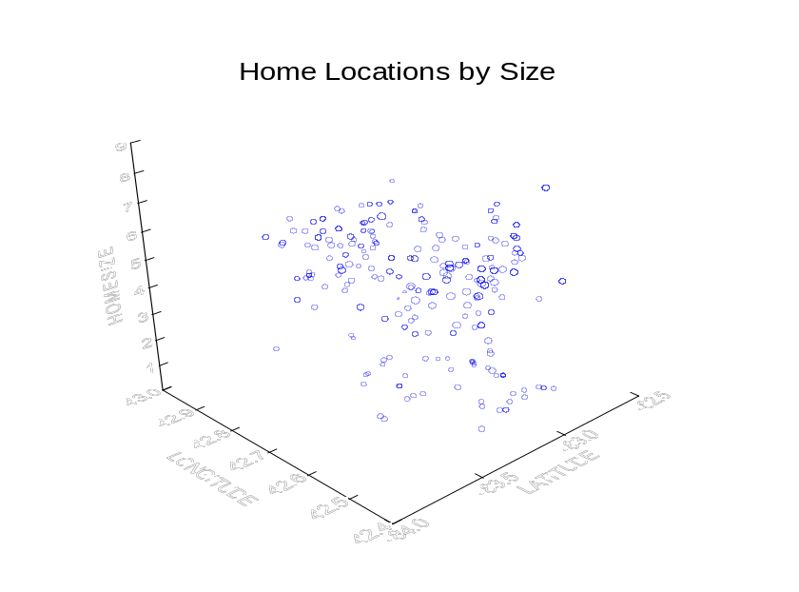

As demonstrated in the above graph, homes in which a larger number of individuals with disabilities lived tended to be further from the main population center and related public transportation. People living independently and semi-independently appeared to have better access to services readily available in the community. This finding lead to the support services organization to be more diligent in locating future homes so that the persons could have better access to employment, shopping and other opportunities.
Human services workers and others who provide support services typically lag in adopting and using new technologies. As GIS and spatial analysis software packages become increasingly user friendly, we can expect their use to grow. Because these software programs can be difficult to use when you begin, look for assistance at the company websites or through colleges and universities. Urban planning and geography departments can provide valuable resources. While each will be different, many university departments, including graduate level social work and urban planning programs can arrange internships for college credit. Most universities with urban planning programs will have access to these software packages, however, if the community organization wishes to purchase these packages, ArcView and TerraSeer cost less than $1,000 each. Many faculty members will provide pro-bono assistance especially if your organization’s project can provide the basis for classroom assignments and possibly lead to publications.

Michael Wolf-Branigin, Ph.D., Associate Professor of Social Work at George Mason University in Virginia teaches courses in research methods, and social policy and social justice. His areas of specialization include disability studies, consumer-choice models, and quality of life outcomes.

